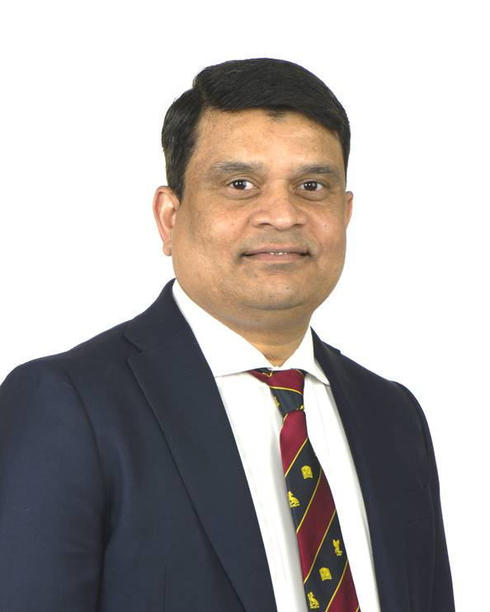

Badri Vijaynagar

It was an extraordinary experience during the BSET endovascular as well as in the BSET travelling fellowship.

The sites (***St Mary’s Hospital and Northwick Park for Endovascular Fellowship; Abano Terme, Italy for Travelling Fellowship***) that I chose for my fellowships allowed me to gain the much needed exposure to complex endovascular procedures. I was exposed to a variety of complex endovascular cases not only in lower limbs but also within the thoracic arch.

Faculty at both hospitals were highly skilled, approachable and considerate towards my training.

During my Endovascular Fellowship, I enhanced my skills in lower-limb revascularisation techniques. Experience at Northwick Park was crucial in gaining experience in complex lower-limb procedures, especially with retrograde access.

The multidisciplinary approach and leadership skills needed to manage complex aortic cases at St Mary's Hospital helped me appreciate the way complex cases can be dealt with. At the end of.my Endovascular Fellowship, I was confident in planning complex lower limb revascularization cases; adept at recanalising SFA occlusions and gained confidence in deploying closure devices.

In my Travelling Fellowship at Abano Terme, I was immensely influenced by the complex pedal work that the unit was performing in diabetic foot disease patients. Few things struck with me during the fellowship - simplicity and standard approach to all cases. Projections to image lower limb arterial tree were standardized and foot views in both AP as well as lateral projections were taken in all patients. Perfusion angiography concept was an innovative concept that I can across during the fellowship.

At the end of my fellowships, I was able to plan complex revascularisation procedures, especially in diabetic foot patients, gain access in both ante-grade and retrograde fashion, deploy stents and use closure devices.

I am grateful to the BSET Training Committee for giving me an opportunity through these Fellowships to greatly advance my endovascular skills, especially in lower-limb procedures.